**ZAP PROXY**

By default you don’t get zap in kali linux. So we’ll install it.

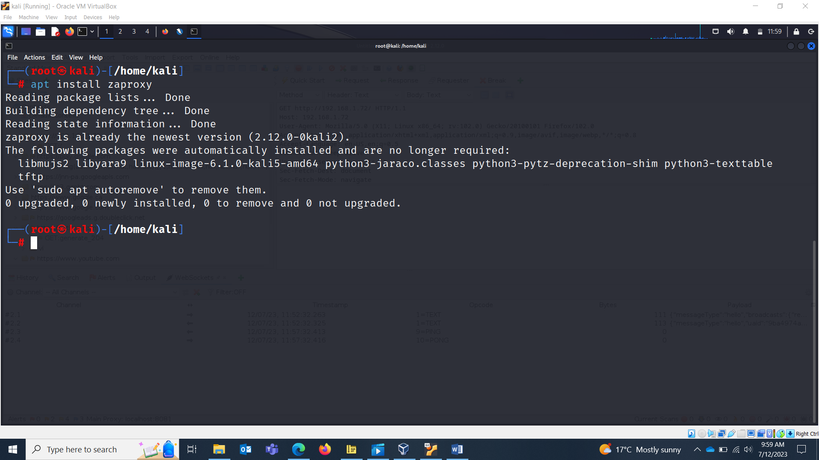

Disabling the local firewall:

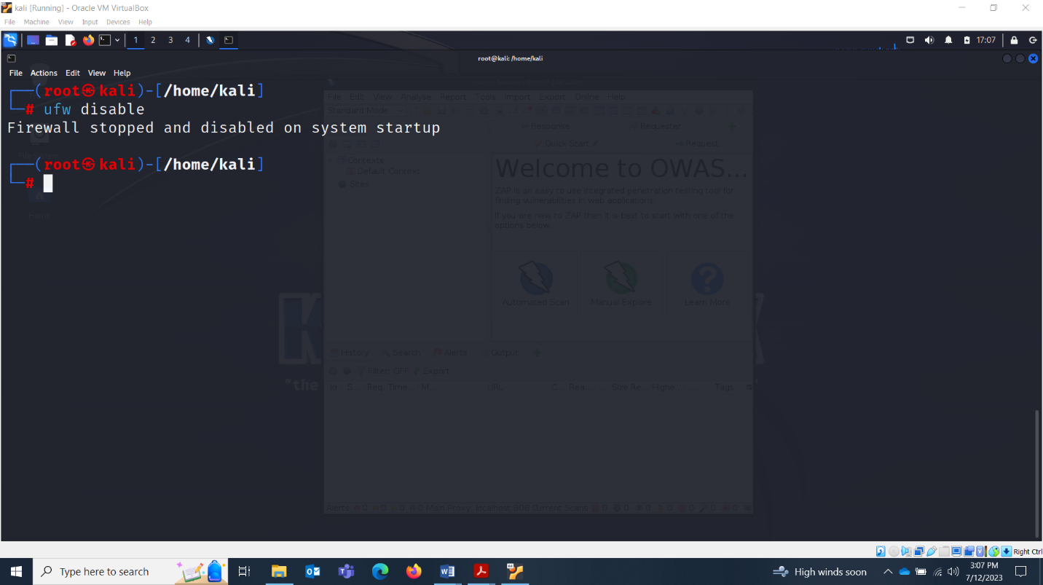

Open ZAP:

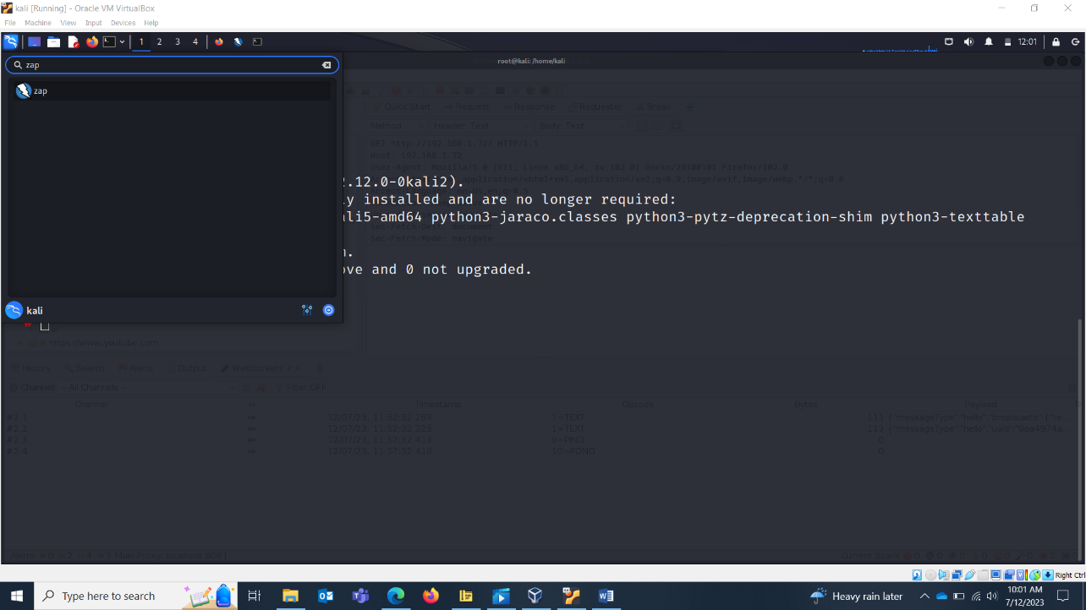

Starting the Proxy:

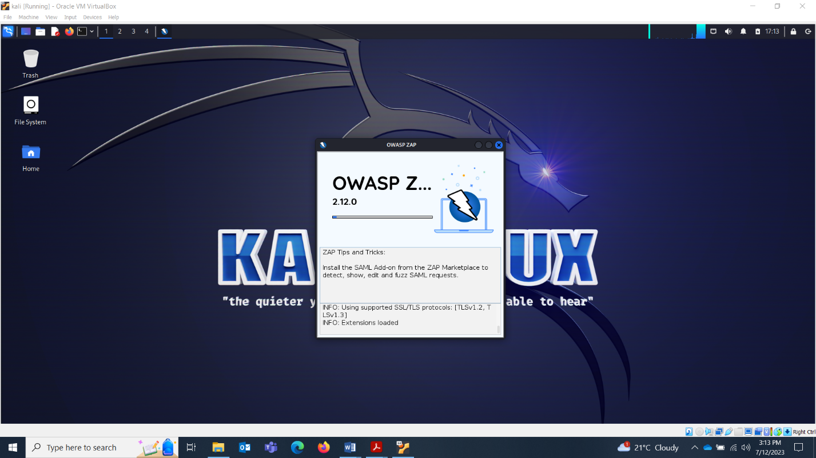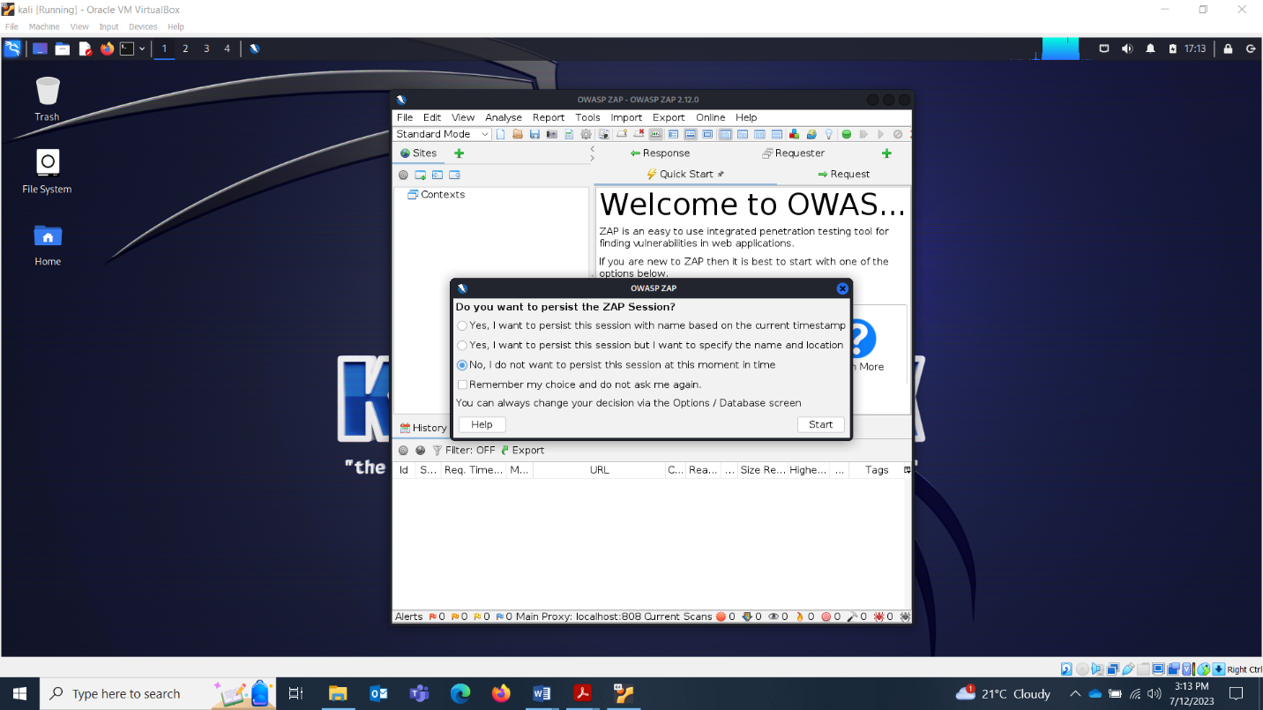

Go to Tools > Options.

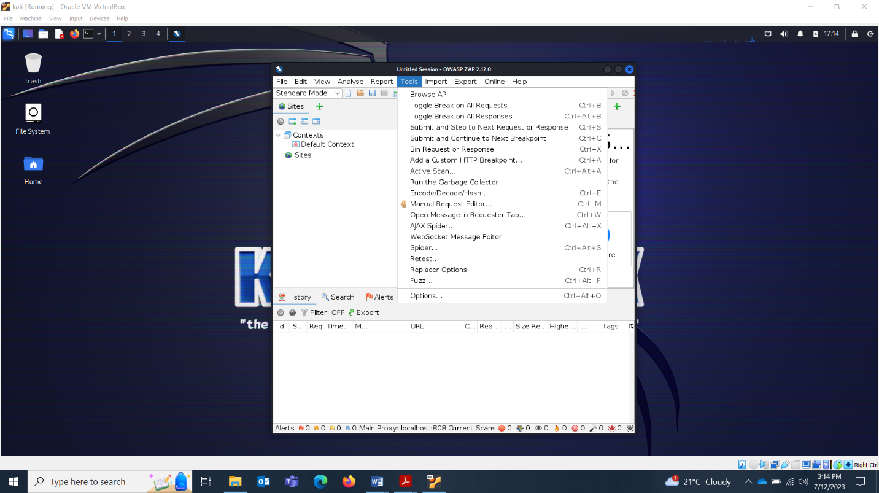

This screen will pop up:

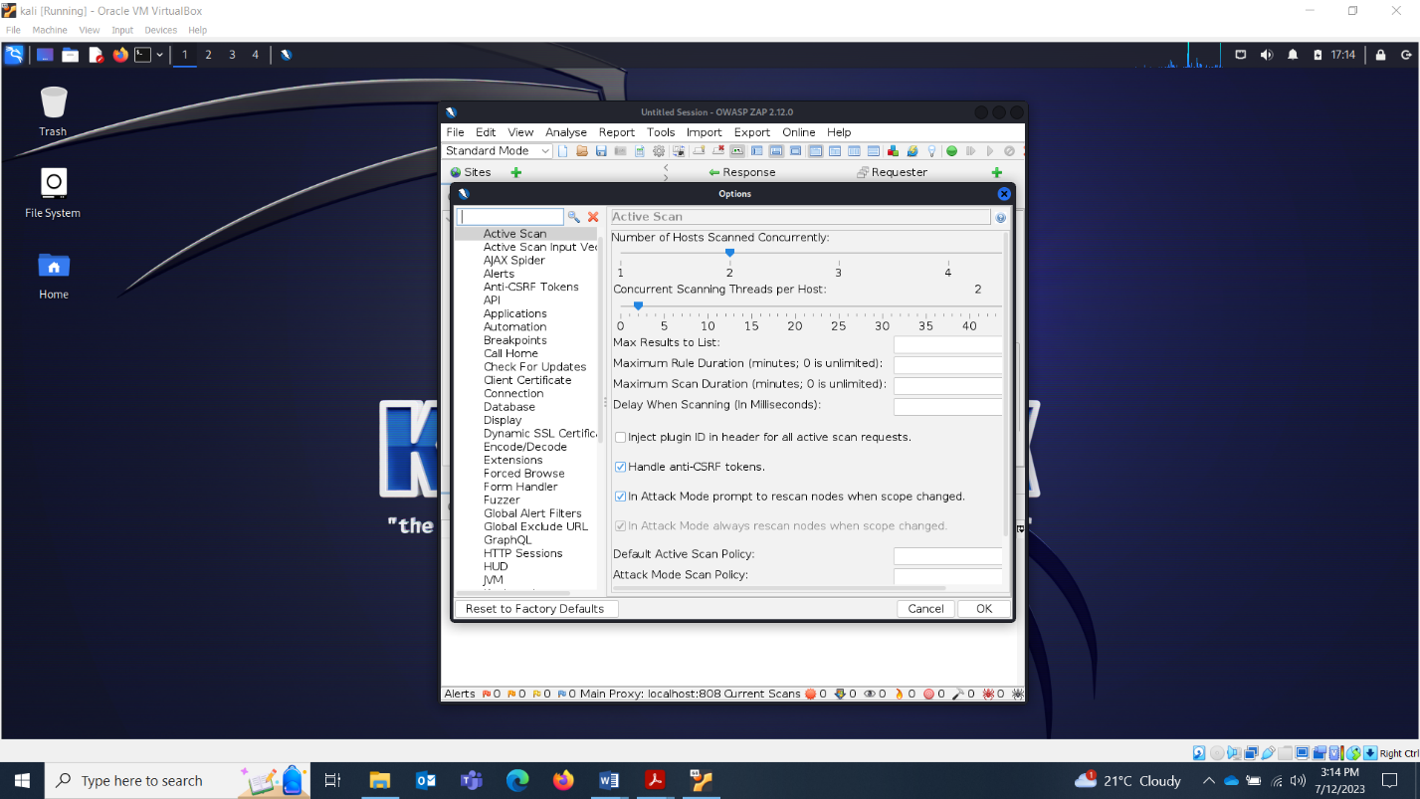

Search Local Proxy at port 8080 or 8081.

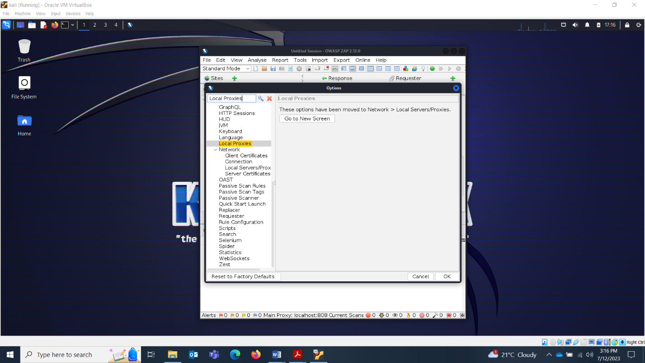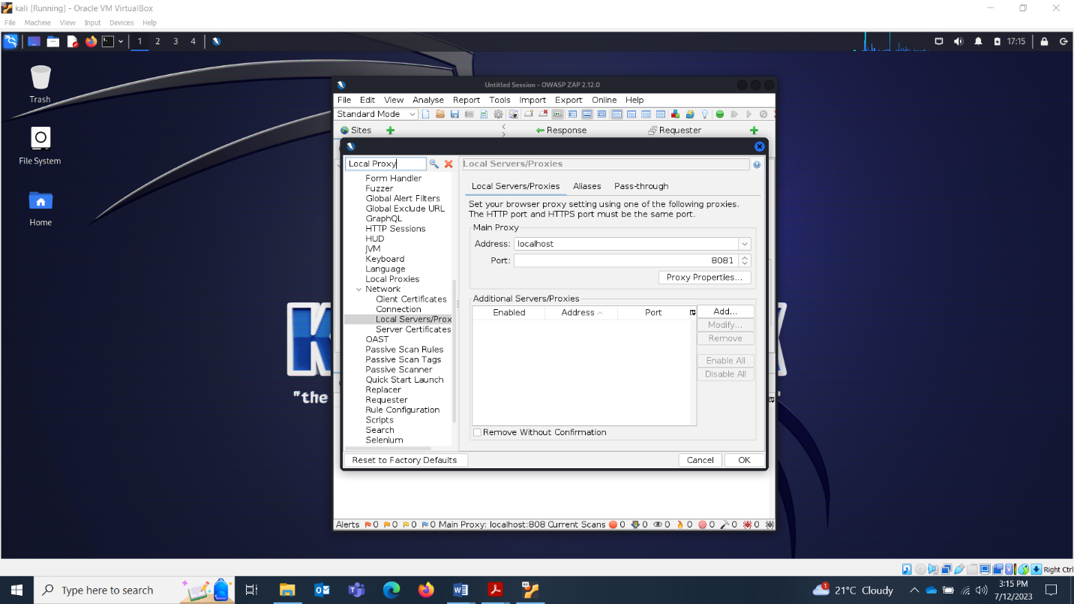

Search Dynamic SSL Certificate.

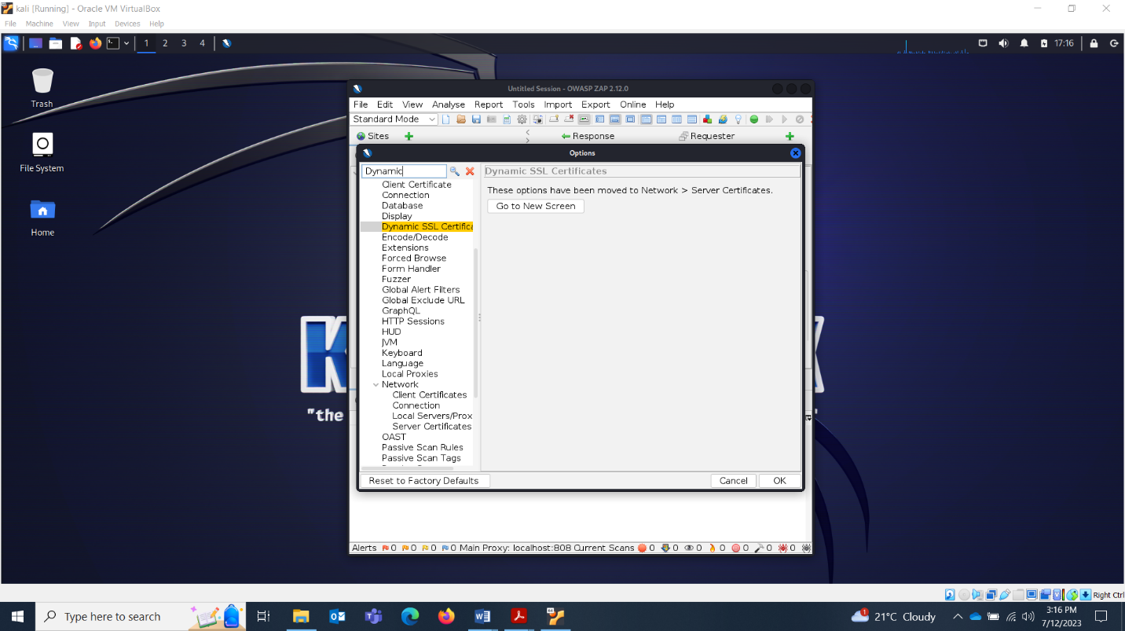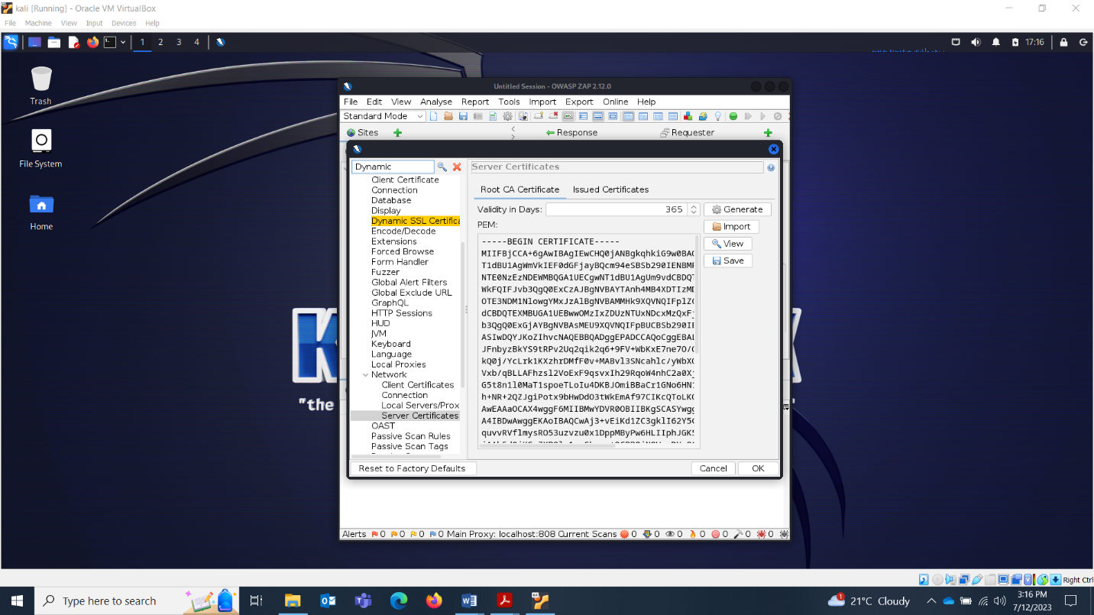

Save the certificate

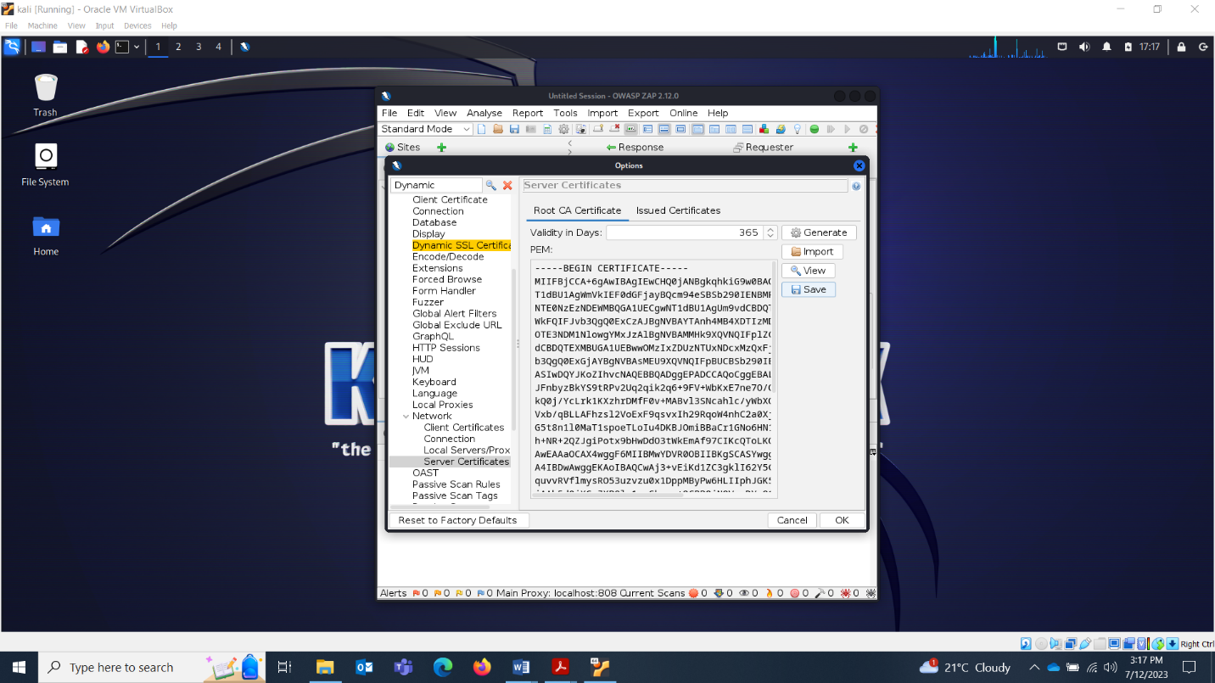 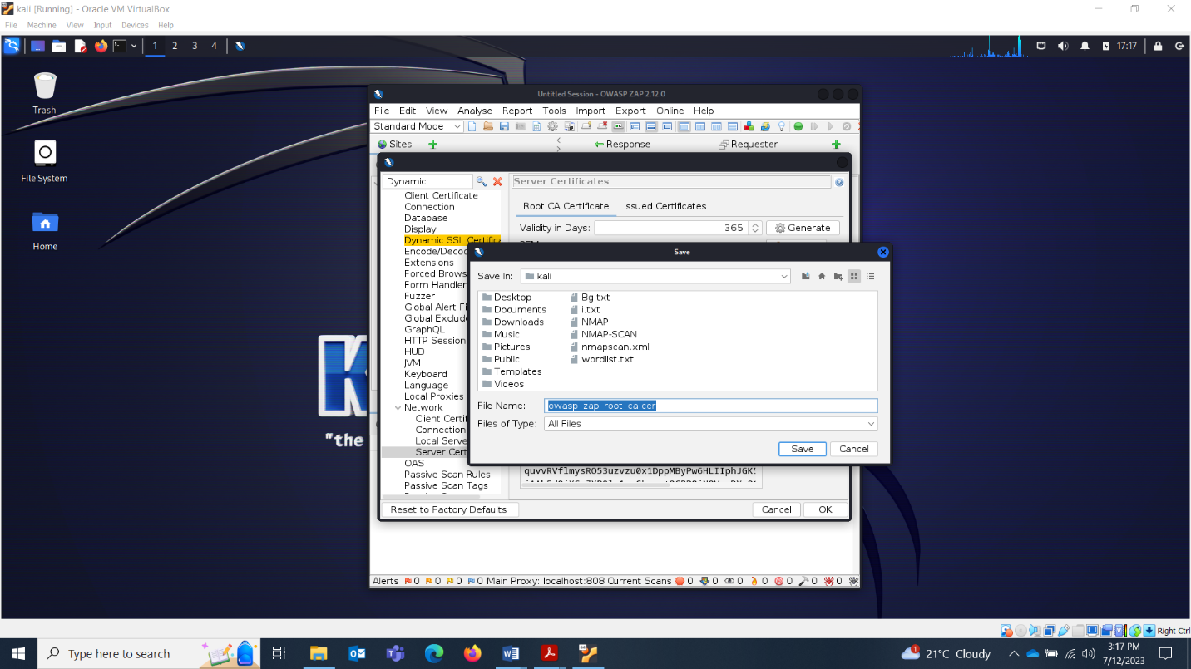

Congratulations! You have configured the proxy properly! Now lets set the proxy in the browser. Go to your browser settings search about:preferences.

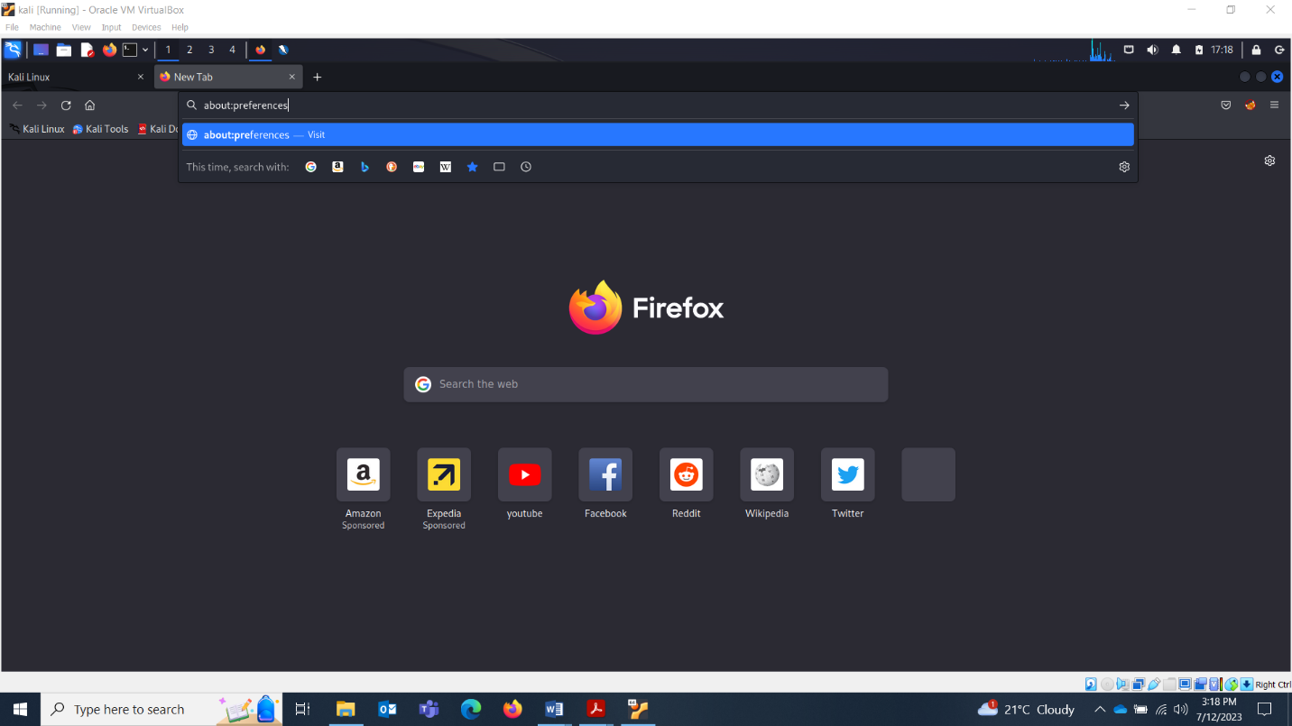

Search network settings.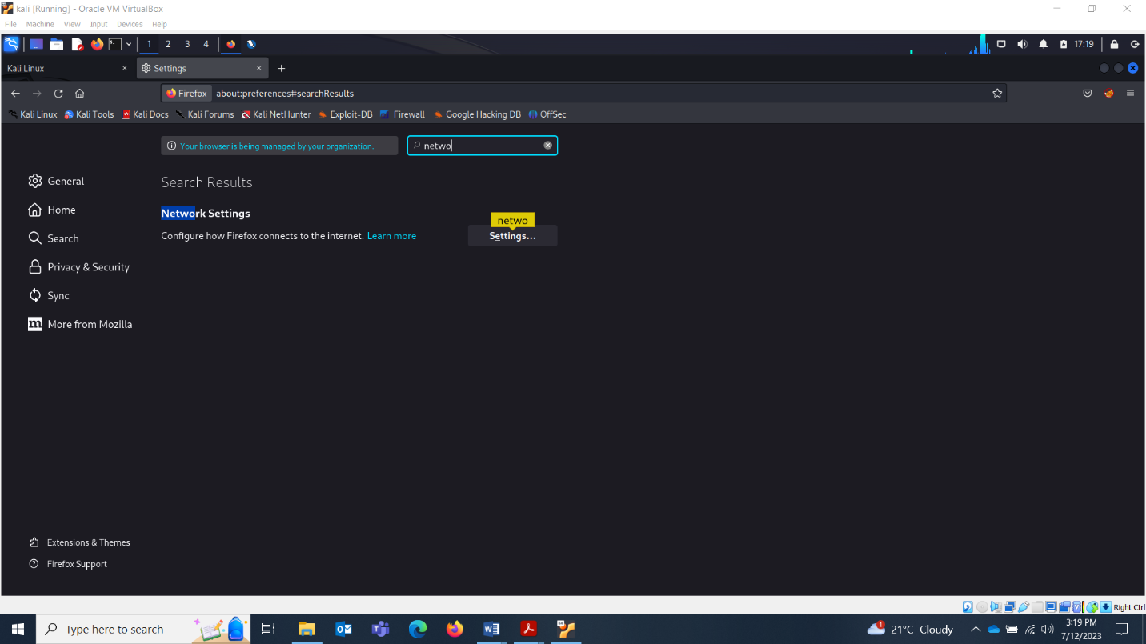

Your proxy settings will get open. Currently it will be on system proxy.

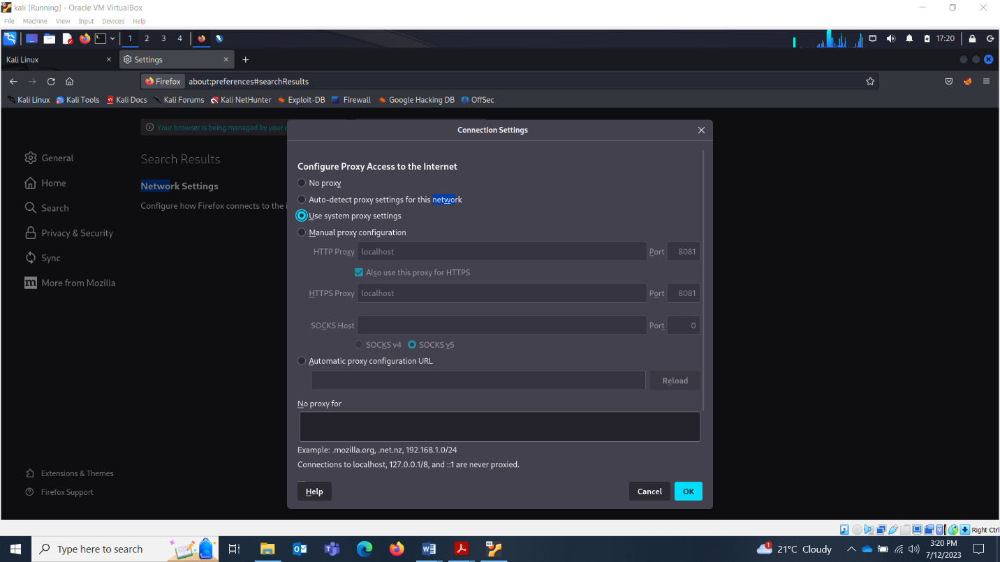

Now you’ll change it to manual proxy which we just configured in ZAP.

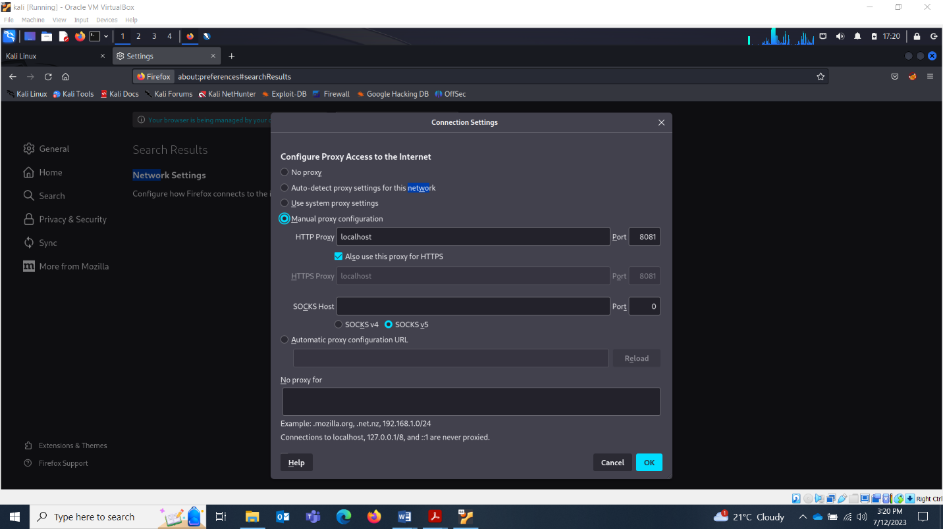

Now search certificate. We’ll export the certificate which we just saved from ZAP.

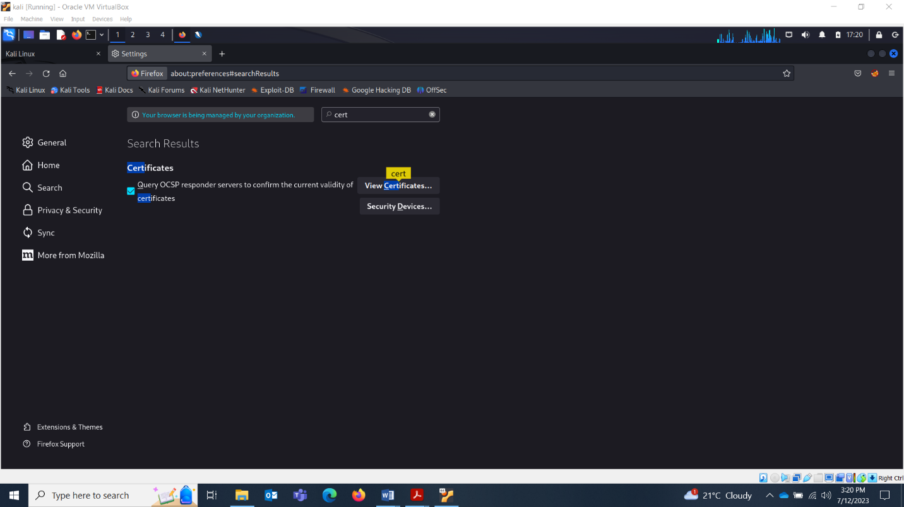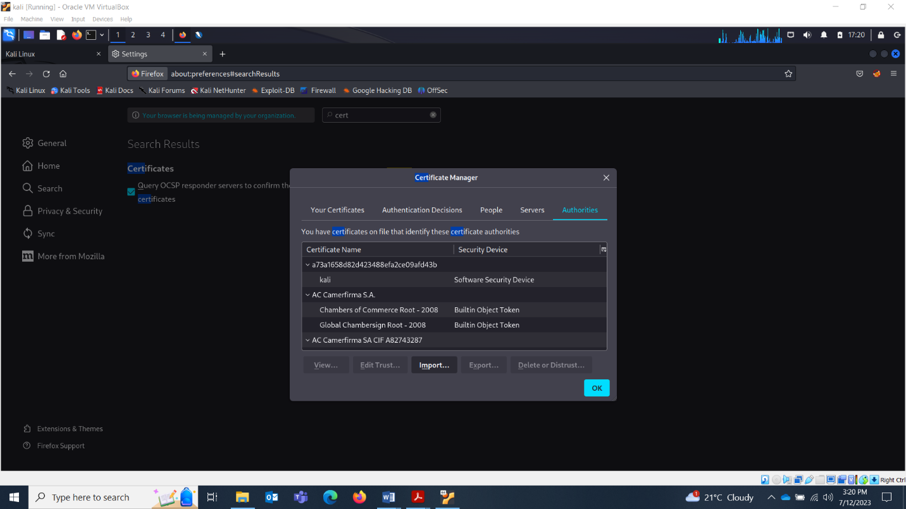

Click on Import and select the certificate which you just saved from ZAP and save it. Don’t forget clicking on OK. Otherwise your settings won’t save.

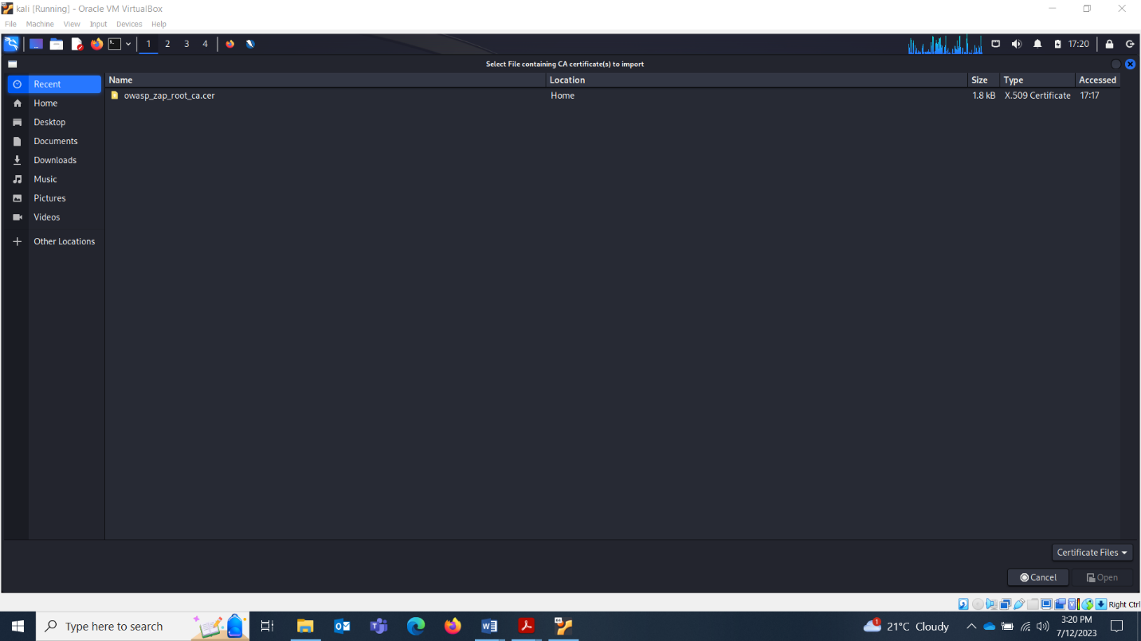

Lets check if the proxy is working or not. Open browser and proxy both. Everything that you’ll search in browser, it will all appear in proxy.

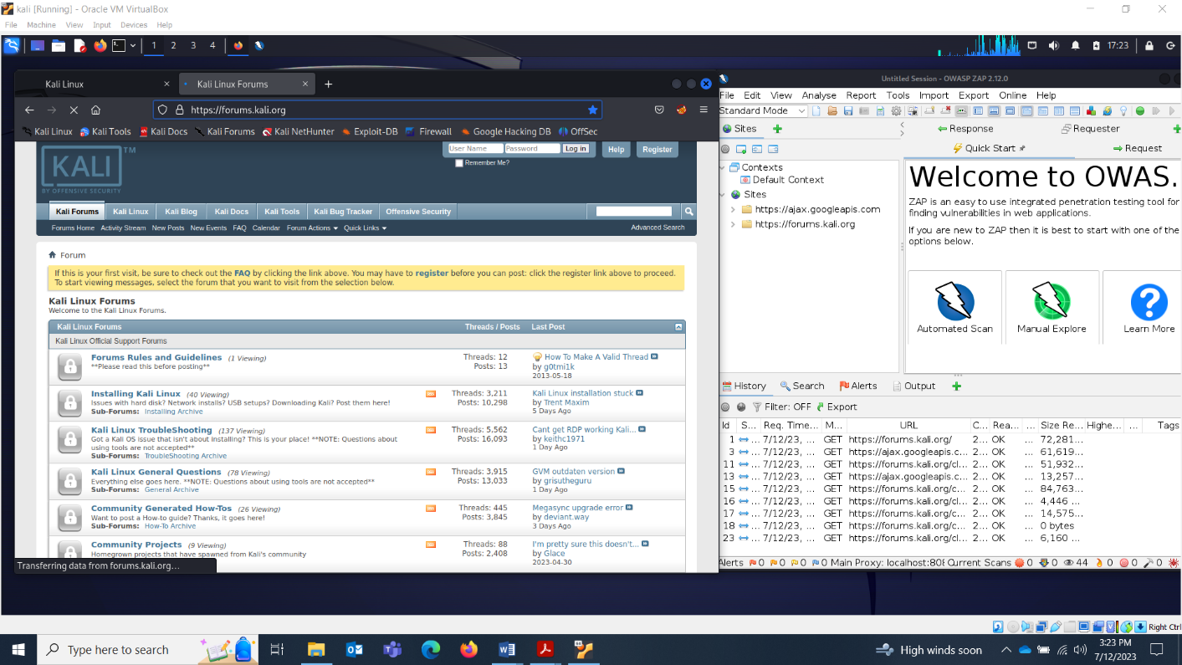

There you go working well!

Lets search youtube.

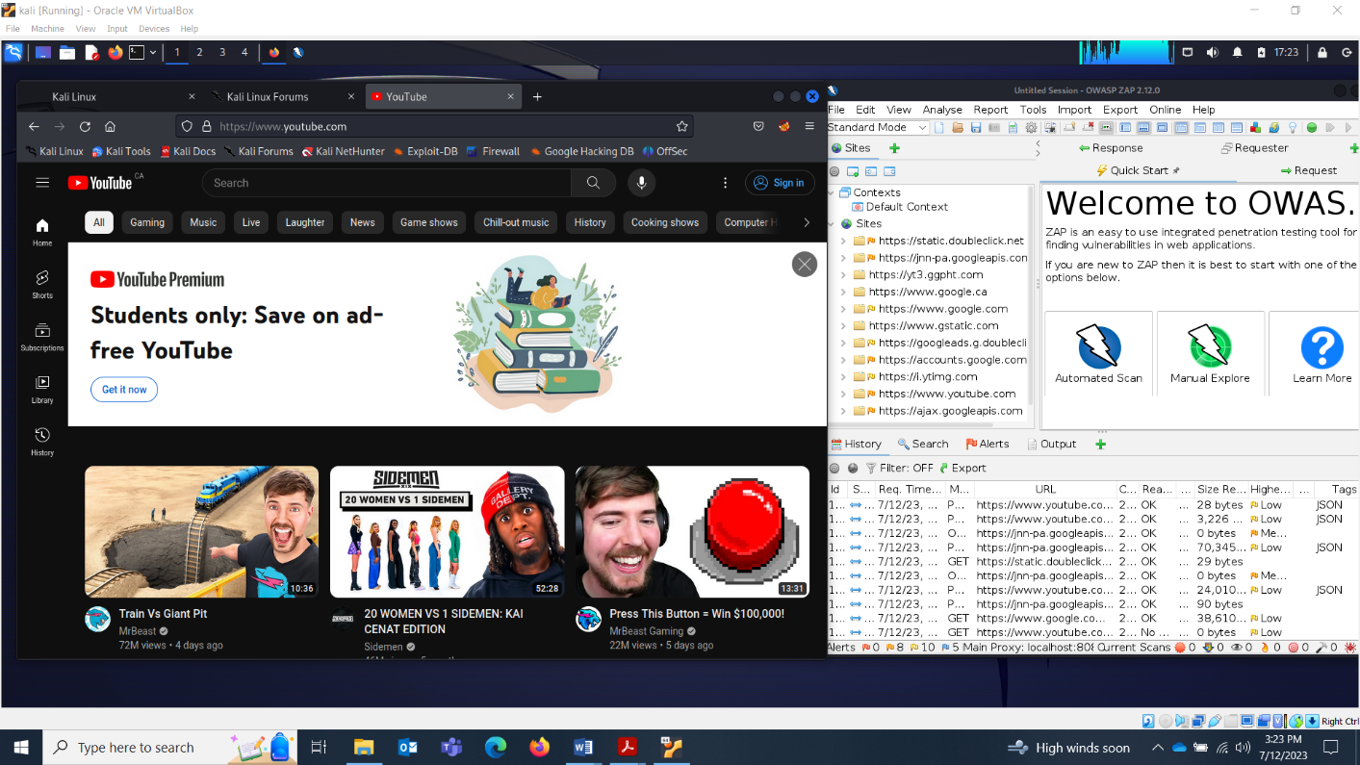

Now get your apache2 webserver up and running. Lets check the status.

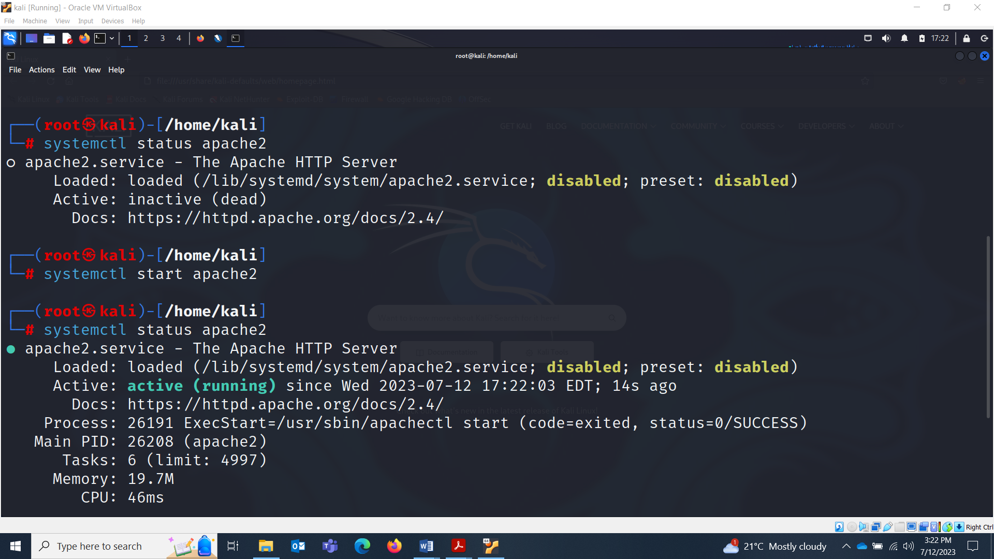

It is inactive. Lets bring it on board.



Check your ip and access the webserver.

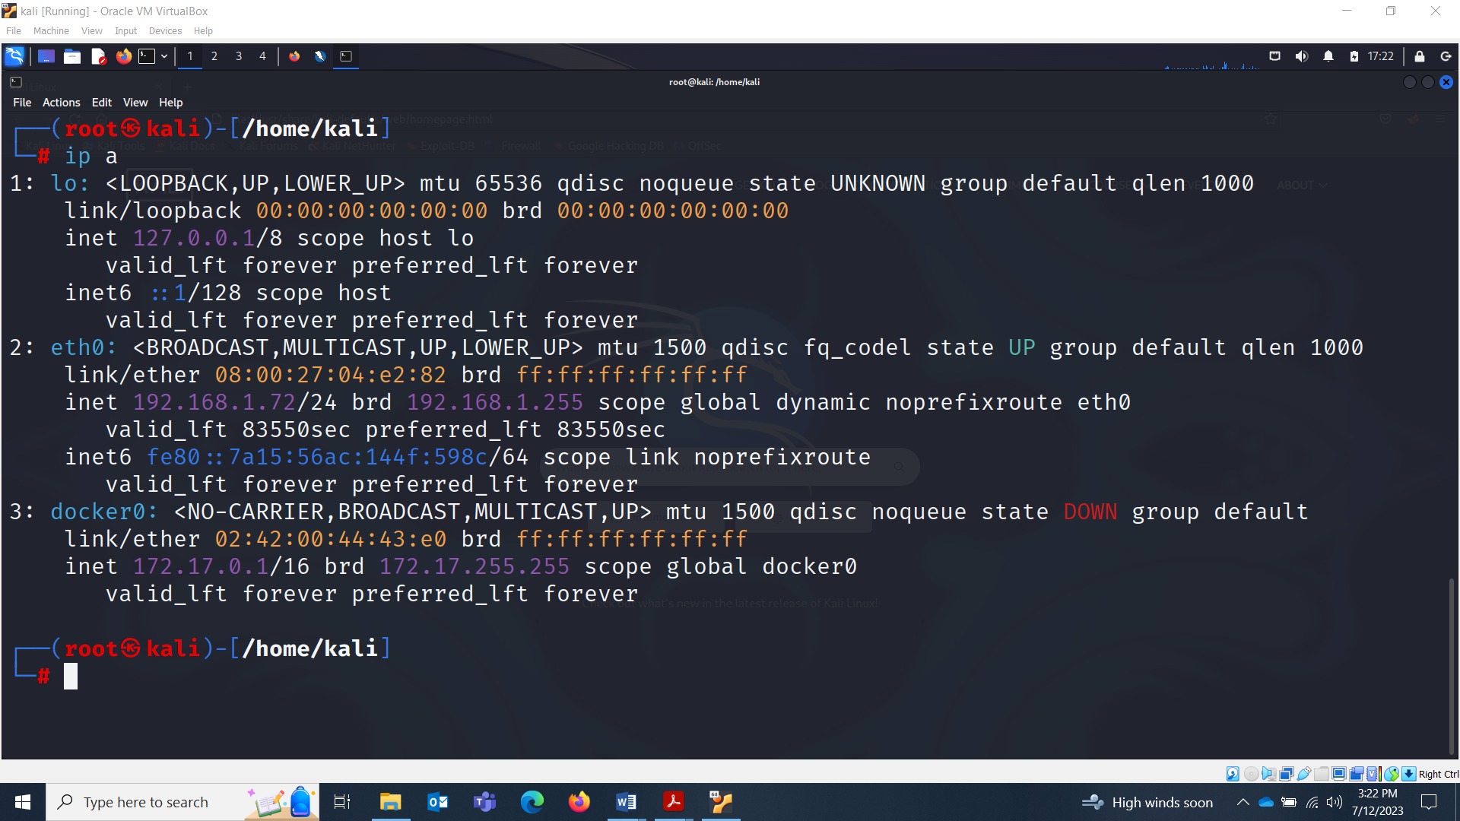

There you go ! We access it and proxy intercepted the traffic.

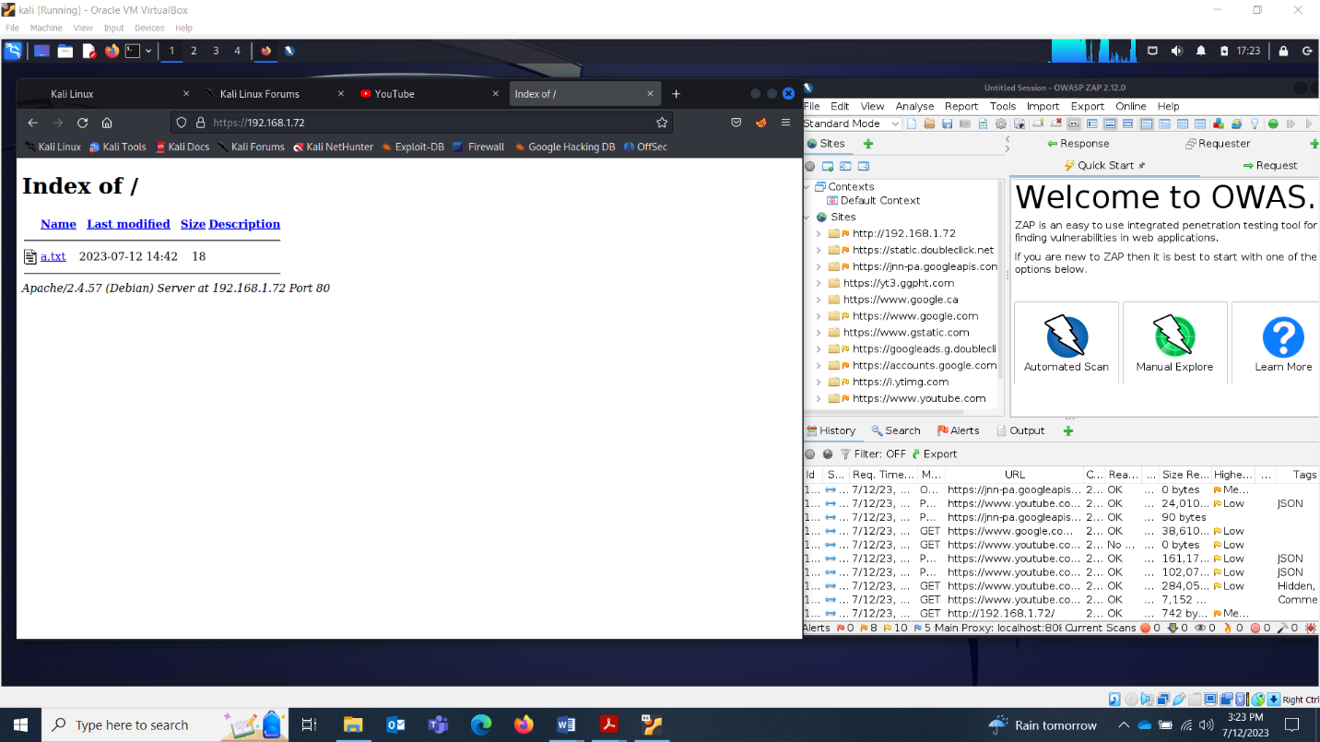

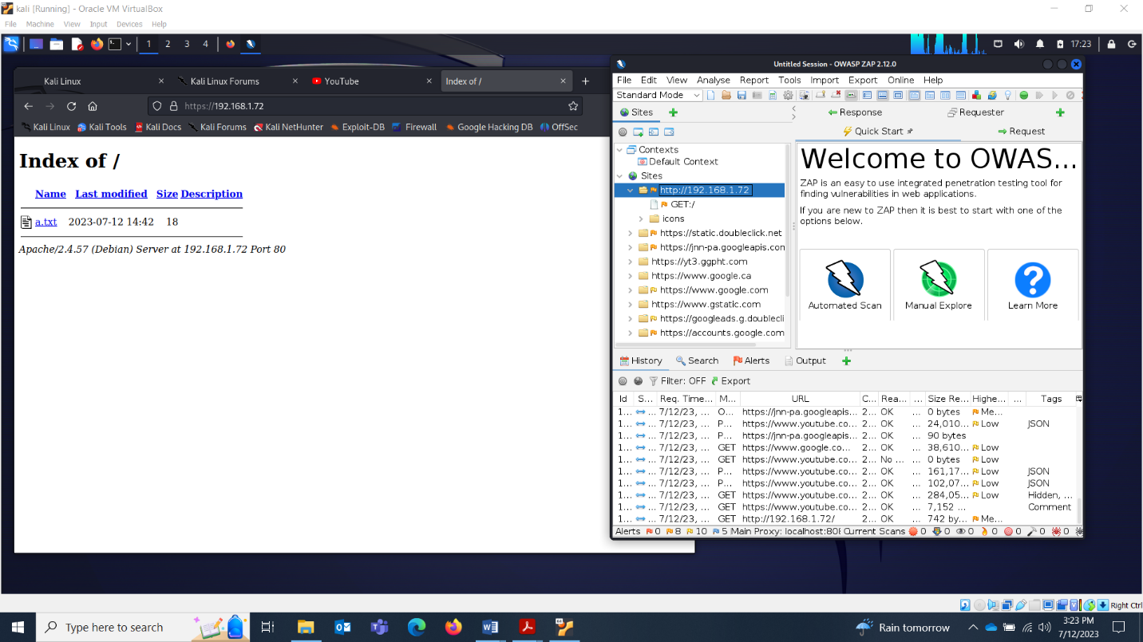

Click on the Get request and break the requests with the green button. The green button is in the Standard Mode row.

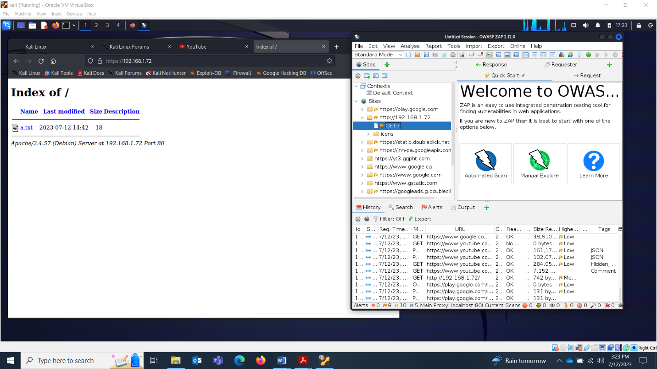

Once it stopped intercepting, it will turn orange.

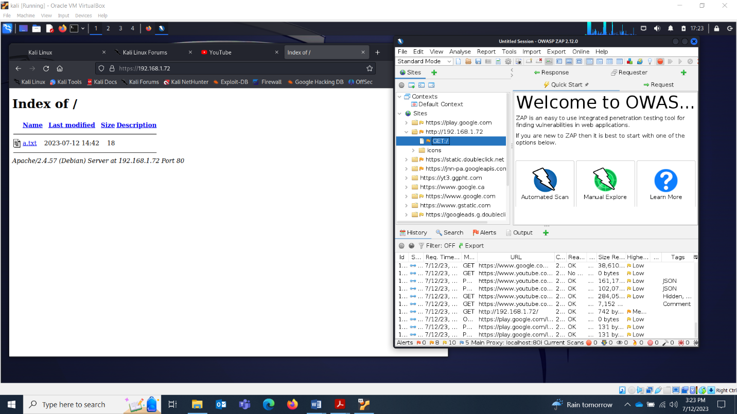

Now refresh your webserver.

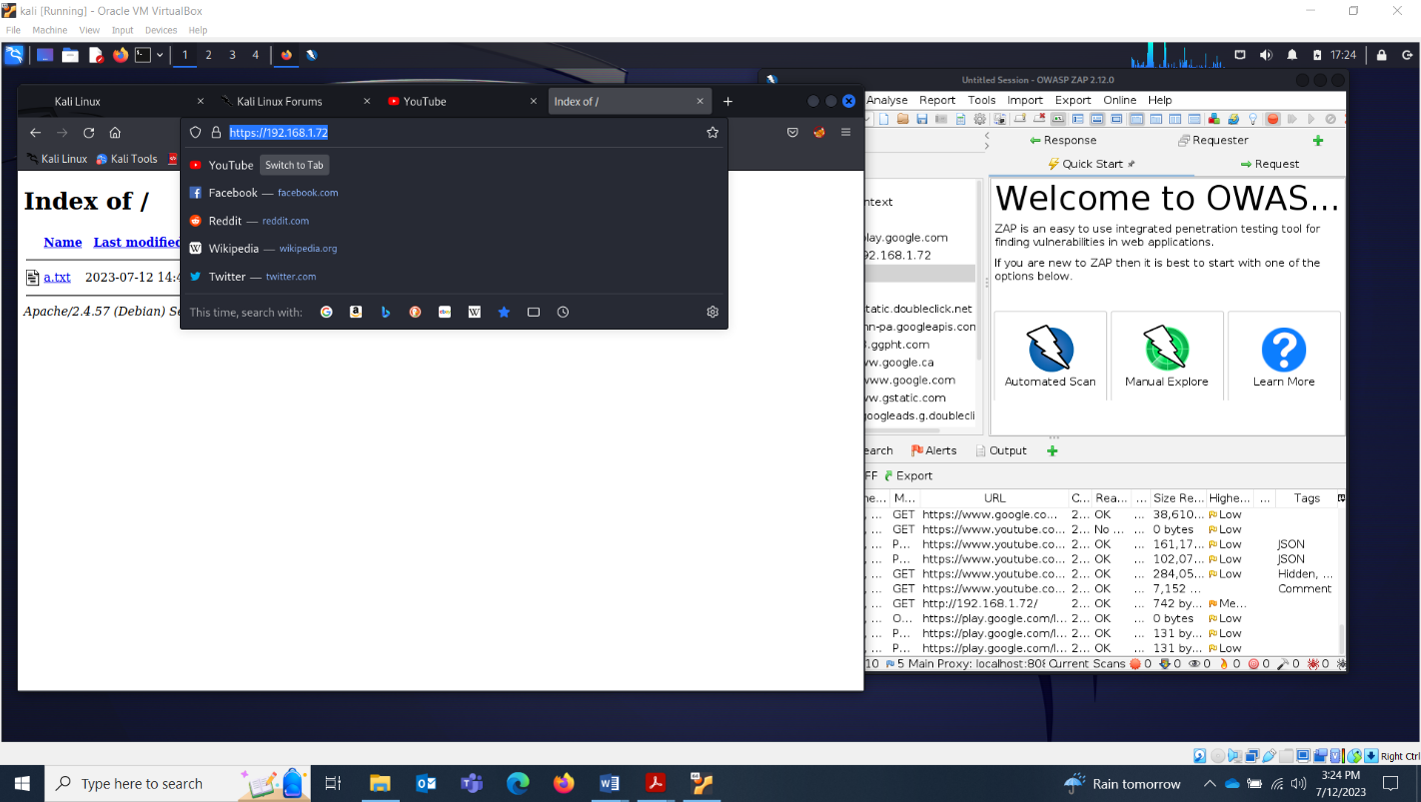

Now forward the request using the arrow button next to orange button

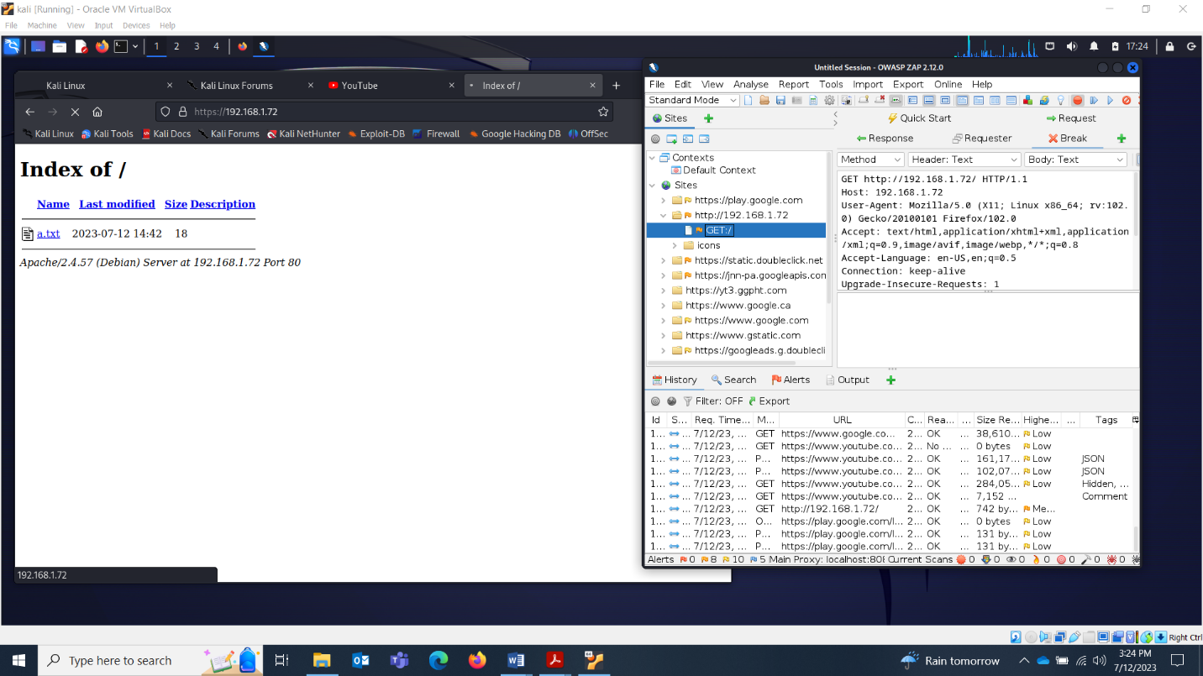

Once you do it. You’ll be able to see the code of the page.

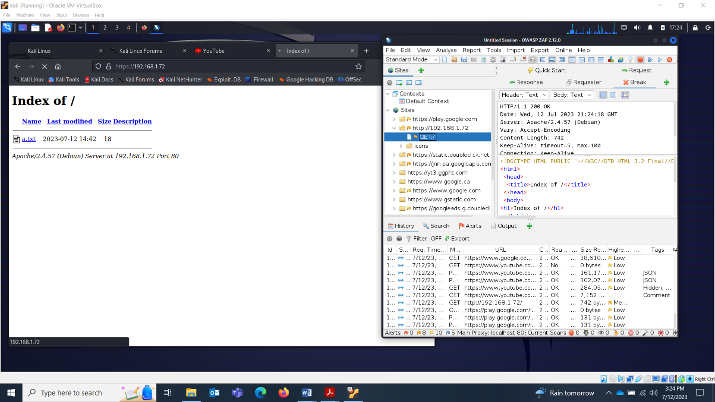

Make changes.

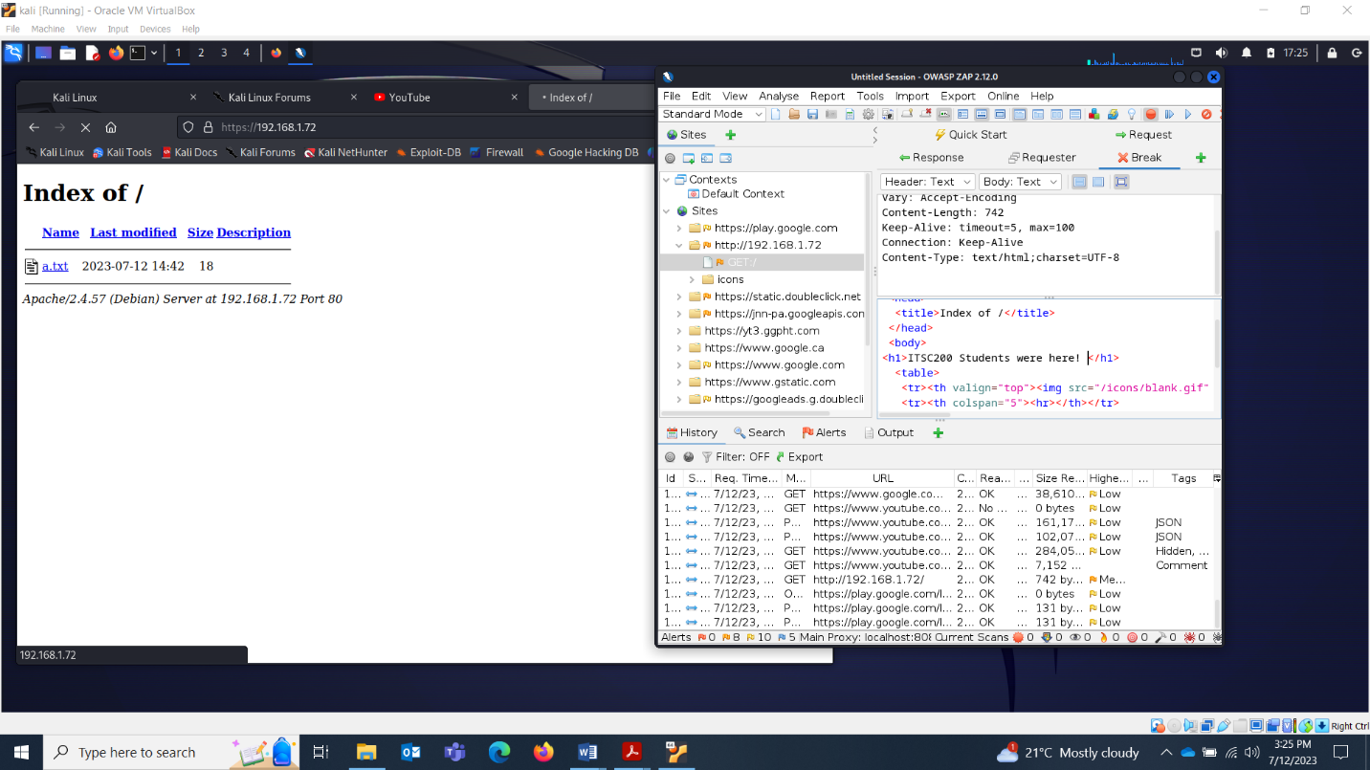

And there you go!

